Luke Halley

20071820  Internet Of Things

Mongo report

Table of Contents

Introduction 3

Documents 4

Database Design 5

Setup Process 7

Trying Out Some Commands 10

Cloud MongoDB service 12

Creating Documents 14

Code 17

# Introduction

This report shows the process of my creation of a NoSQL database based on the music streaming platform “Spotify”. Spotify is a music podcast and video streaming service that was officially launched on 7 October 2008. It is developed by startup Spotify AB in Stockholm Sweden. Music can be browsed through or searched for by parameters such as artist album genre playlist or record label (<https://en.wikipedia.org/wiki/Spotify)>.

A music streaming service similar to Spotify & Apple Music. The service would have access to millions of songs across different genres and styles. The service will offer category’s for users to find the music they want to listen to. These category’s would be **Artists Releases Tracks Albums Playlist Labels.** Users would navigate through the database using the an Graphical User Interface (GUI) (E.g. Desktop App Mobile App). When a user would select a category to explore it would show a list unique to then based on their profile. For example when navigating the **Artists** section the user would be shown his/her artist that they are following.

# Documents

**Documents: Users, Playlists, Tracks, Artists, Album**

Each **User** has an:

* *ID*
* *Name*
* *Plan*
* *Array of Artists they are following*
* *Array of Albums in the users collection*
* *Array of Tracks in the users collection*
* *Array of Playlists the user is following.*

Each **Artist** has an:

* *ID*
* *Name*
* *Number of followers*
* *Array of the Artists tracks*
* *An array of the artist’s Albums*

Every **Track** has an:

* *ID* Title
* Artist ID
* Genre Number of plays
* An array of what Playlist(s) the track is included in

Every **Album** has an:

* *ID*
* Title
* Artist
* Genre
* Release
* Date
* Number of copies sold
* An array of what Playlist(s) the track is included in.

Every **Playlist** has an:

* *ID*
* Title
* Description
* An array of what the playlist’s track ID(s)
* An array of the number of user(s) following the playlist

# Database Design

When designing my NoSQL database I used a previous design which was used for a relational database. This was implanted using Oracle SQL. Oracle Database (commonly referred to as Oracle RDBMS or simply as Oracle) is an object-relational database management system produced and marketed by Oracle Corporation. (<https://en.wikipedia.org/wiki/Oracle_Database)>.

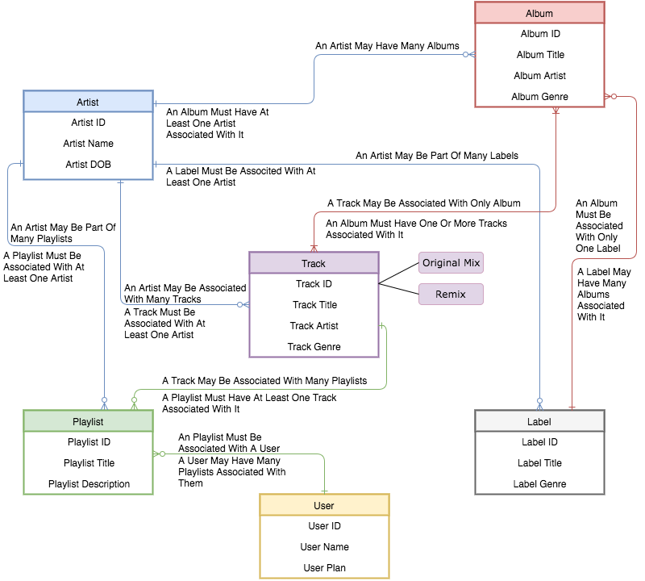

Database design is the process of producing a detailed data model of database. This data model contains all the needed logical and physical design choices and physical storage parameters needed to generate a design in a data definition language, which can then be used to create a database. A fully attributed data model contains detailed attributes for each entity.

Principally, and most correctly, it can be thought of as the logical design of the base data structures used to store the data. In the relational model these are the tables and views. In an object database the entities and relationships map directly to object classes and named relationships.

The process of doing database design generally consists of a number of steps which will be carried out by the database designer. Usually, the designer must:

• Determine the data to be stored in the database.

• Determine the relationships between the different data elements.

• Superimpose a logical structure upon the data on the basis of these relationships.

To design my database I used the online diagram tool, Creately (https://creately.com).

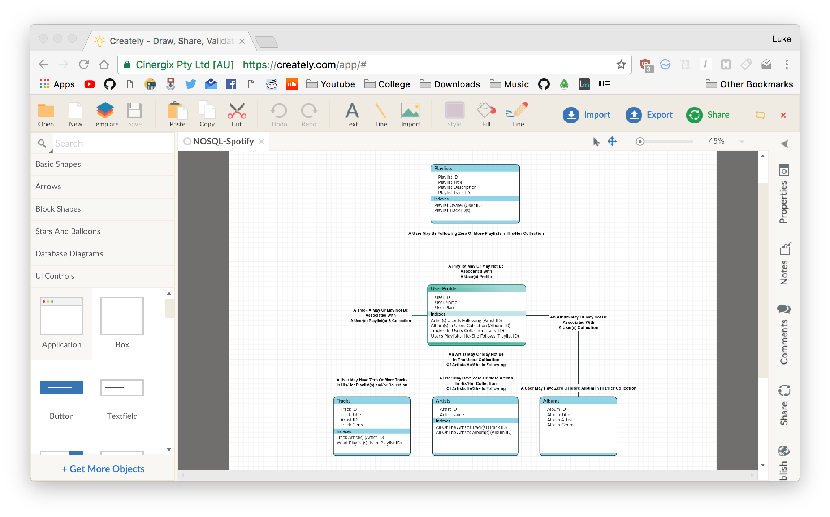

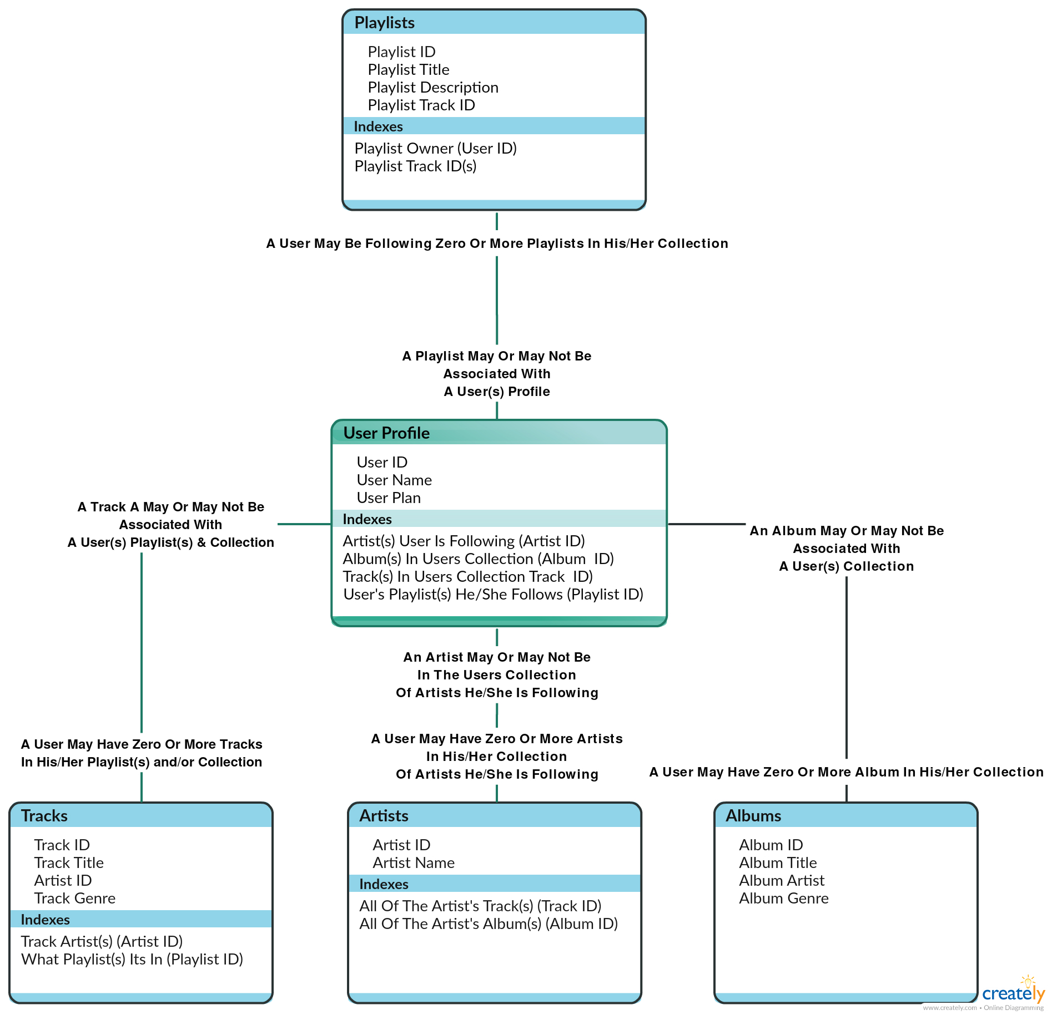

# Setup Process

#### YouTube

The installation process was done by following a YouTube tutorial from the user “Derek Banas”. In this tutorial the installation of MongoDB for both Windows systems and Mac OSX systems was shown (In my case I used the Mac segment due to me running a Macintosh machine).

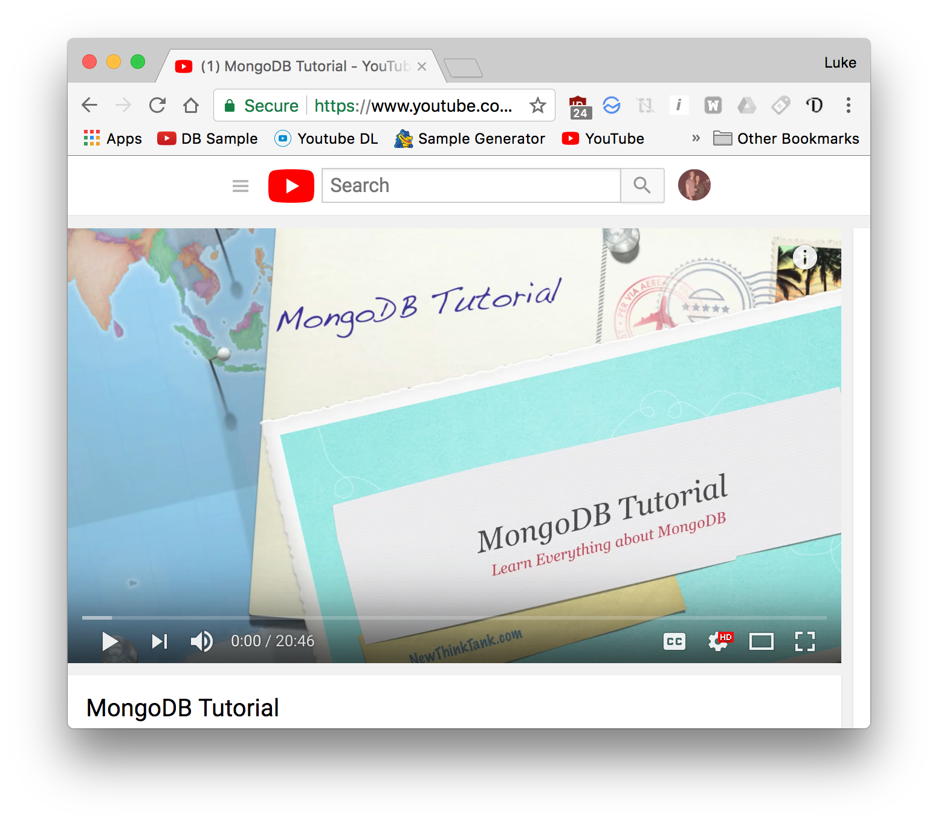

The first step of this process was installing *Homebrew.* Homebrew is a free and open-source software package management system that simplifies the installation of software on Apple's macOS operating.

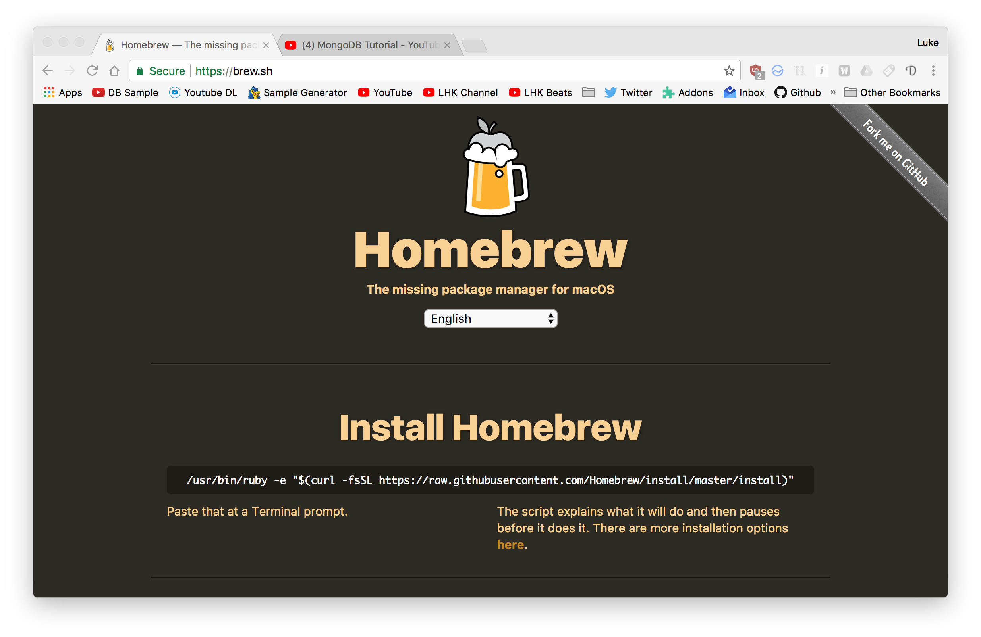

This was done at the command line. After this an update command was used to make sure all software was up to date.

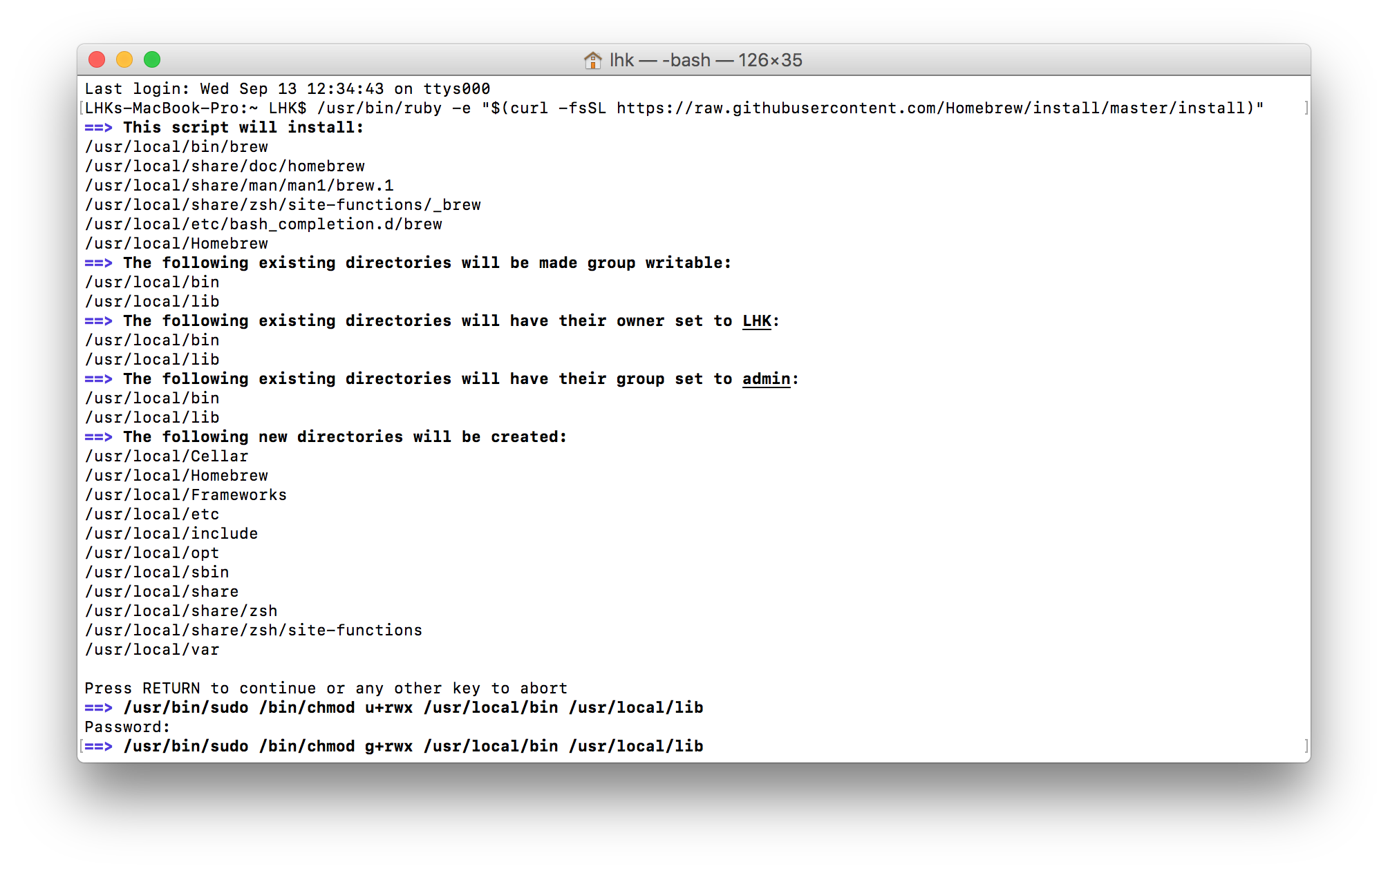

Figure 1: /usr/bin/ruby -e "$(curl -fsSL https://raw.githubusercontent.com/Homebrew/install/master/install)"

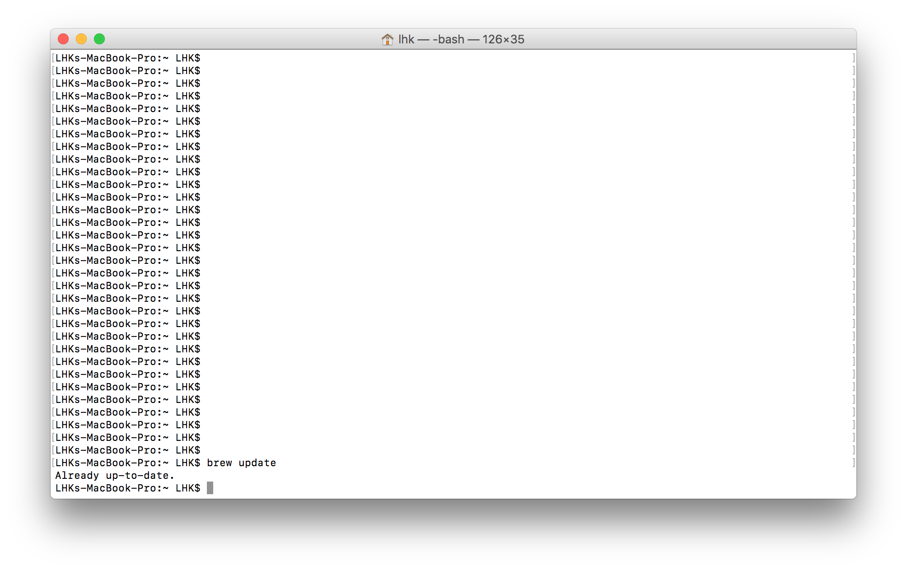

Figure 2: brew update

The next step was to issue the command to install MongoDB itself which was a simple one line command due to the Homebrew software. Before using homebrew I attempted to install MongoDB via a binary file which is available to download on the website. During this process I ran into multiple problems when trying to get it to work.

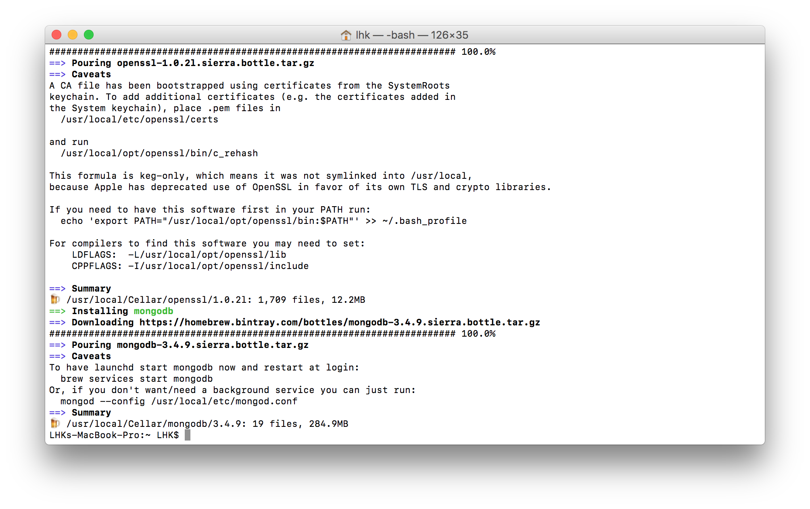

Figure 3: brew install mongodb

After installing mongodb a directory had to be made in order for MongoDB to function correctly. After the directory was made I changed the read and write permissions of the folder so the program would have access for its operation. *Note: Commands below are separated by [].*

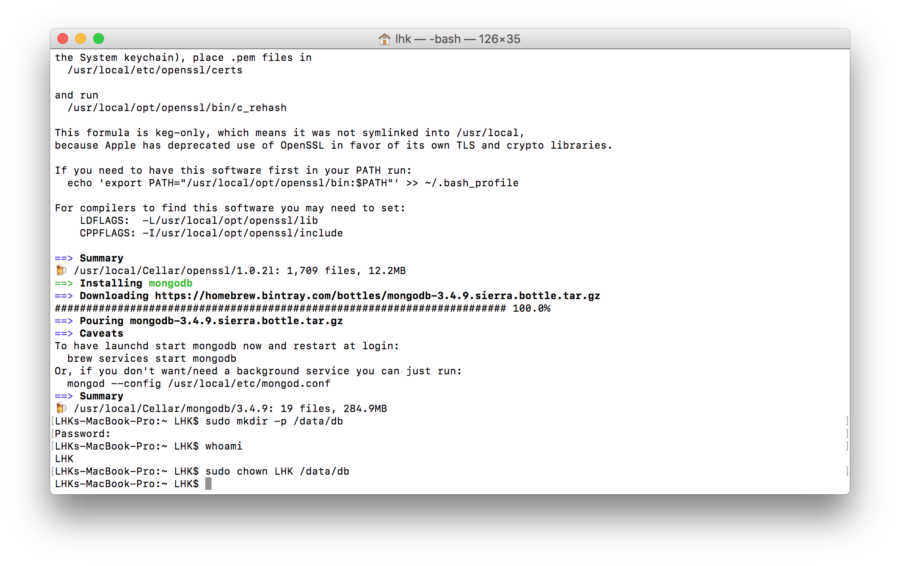

Figure 4: [sudo mkdir -p /data/db] + [sudo chown LHK /data/db]

After all of this was done MongoDB was ready to run. When the commands below were issued the software began to run and did its necessary start-up processes. After the database said it was waiting for its command on the given port I proceeded to open a new terminal window to issue commands to the database. After switching to a new window I started the shell process which is used to access the database. This is accomplished by opening another command line and moving to \mongo\bin.

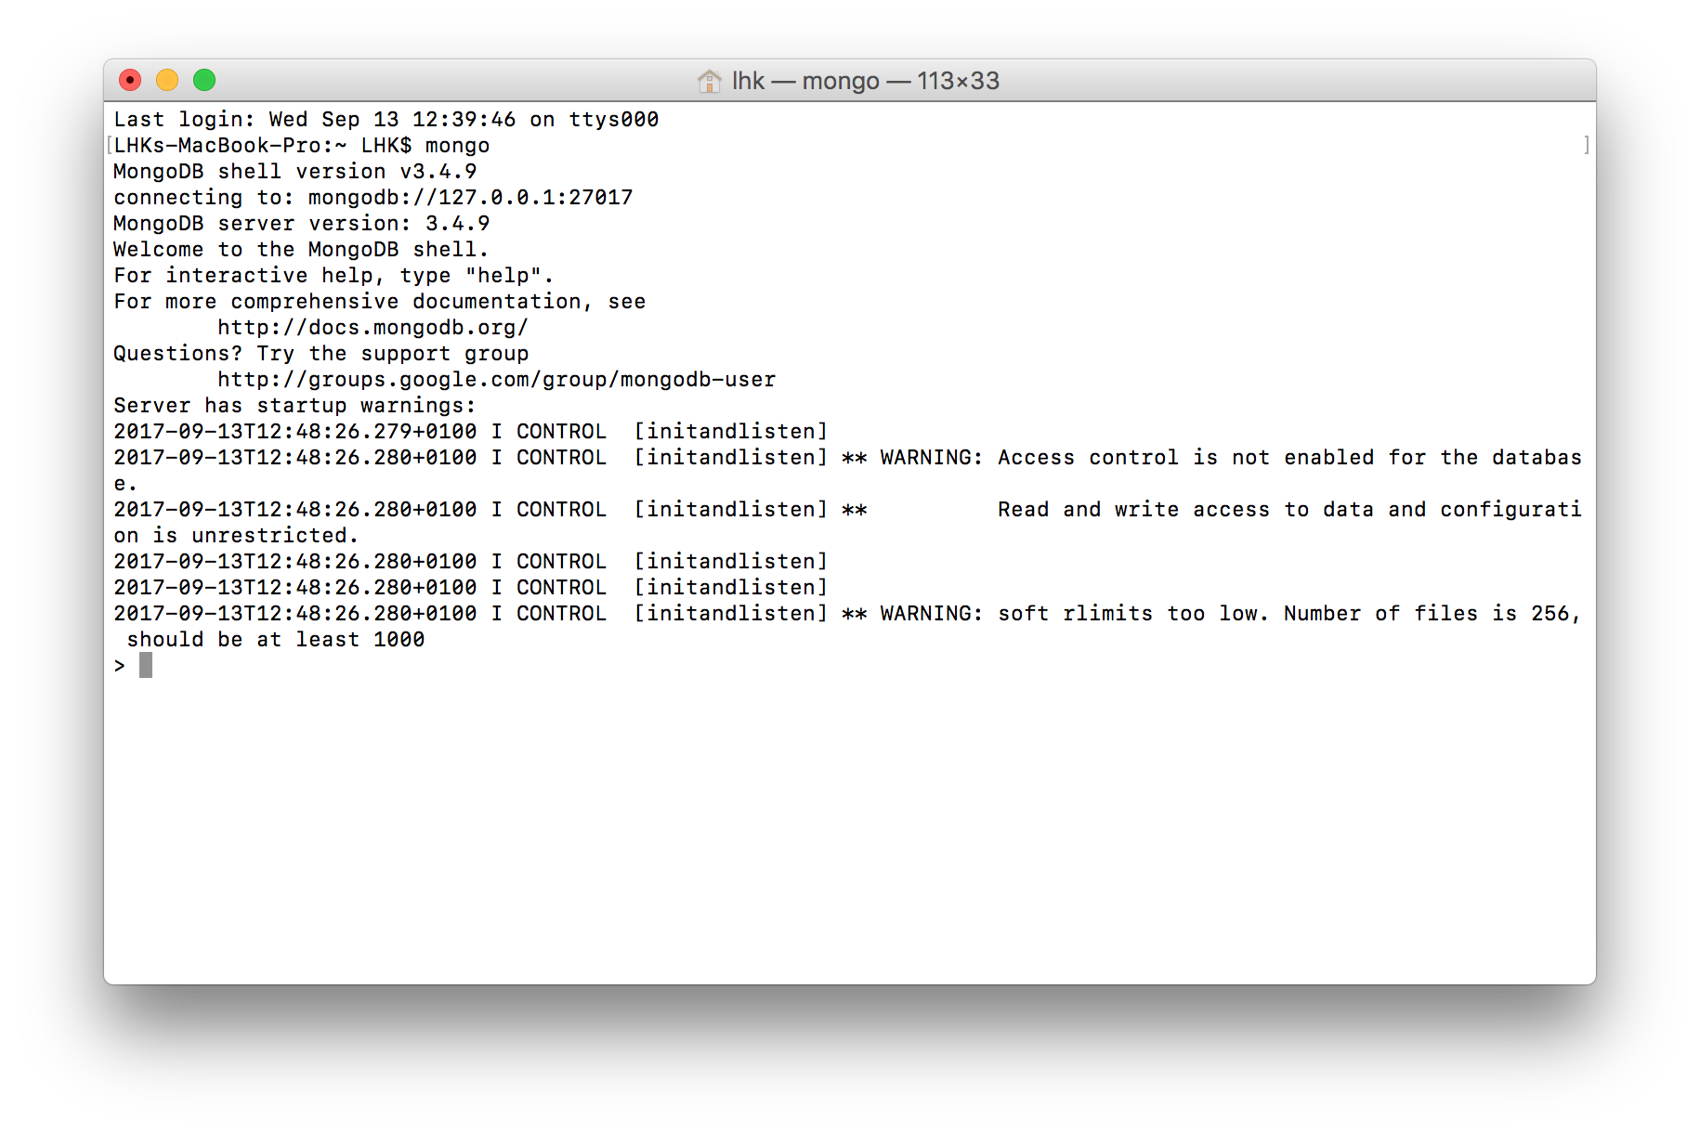

Figure 5: mongo

At this point the database is now fully installed.

# Trying Out Some Commands

Now that the database is installed I tried some simple commands which were given to me in the first lab of the NoSQL module. During this process I learned all these commands below are case sensitive at the start I attempted to use these commands with a uppercase letter at the start which gave me an error.

|  |  |
| --- | --- |
| show dbs | Shows the existing DBs. |
| use <db name> | Turns the focus to the database named. |
| db | Shows the name of the database which has the current focus. |
| help | Gives help with commands. |
| show collections | Shows the collections which exist in the current DB. |

**show dbs:** show database names

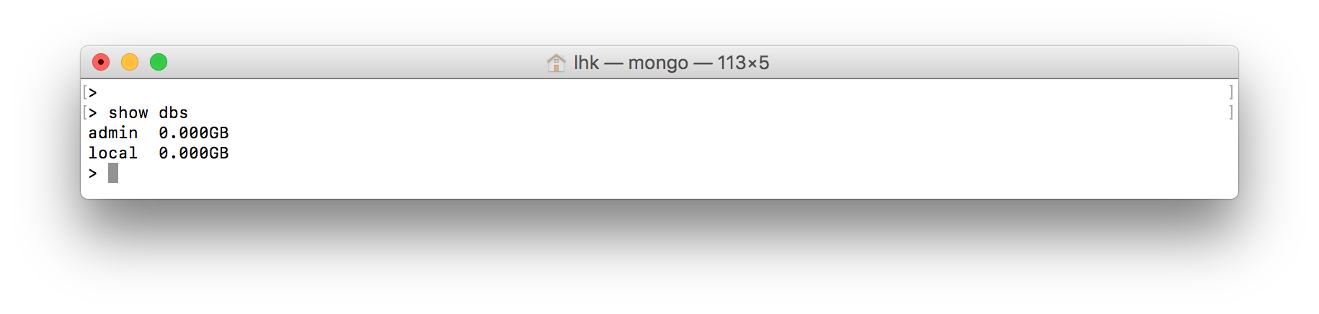**use <db name>:** set current database

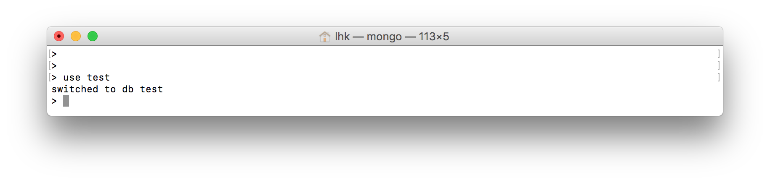

**db:** shows current database in use

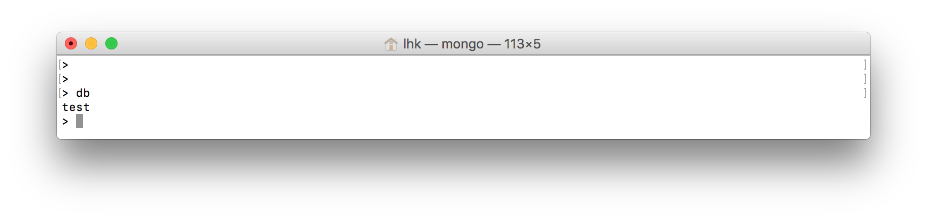

**help:** shows commands available

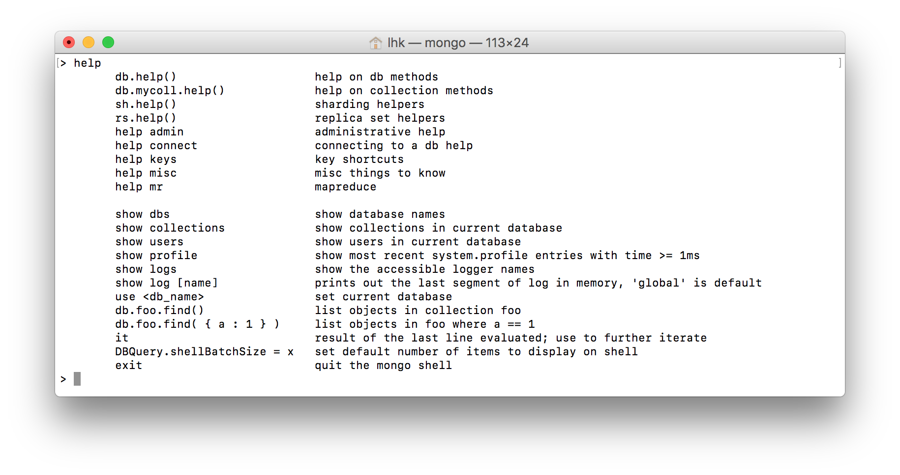

**show collections:** show all collections available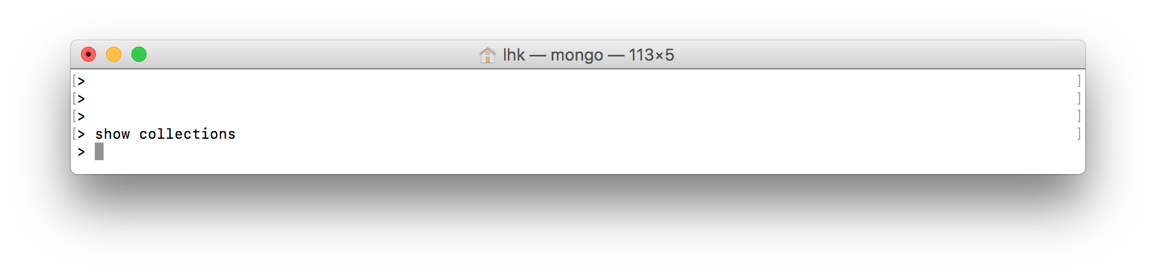

# Cloud MongoDB service

The MongoDB cloud service I used was mLab. mLab is a fully managed cloud database service featuring automated provisioning and scaling of MongoDB databases backup and recovery 24/7 monitoring and alerting web-based management tools and expert support. mLab's Database-as-a-Service platform powers hundreds of thousands of databases across AWS Azure and Google and allows developers to focus their attention on product development instead of operations. Since its inception six years ago mLab has grown like wildfire and now manages over half a million databases across three major cloud providers in 36 datacentres worldwide.

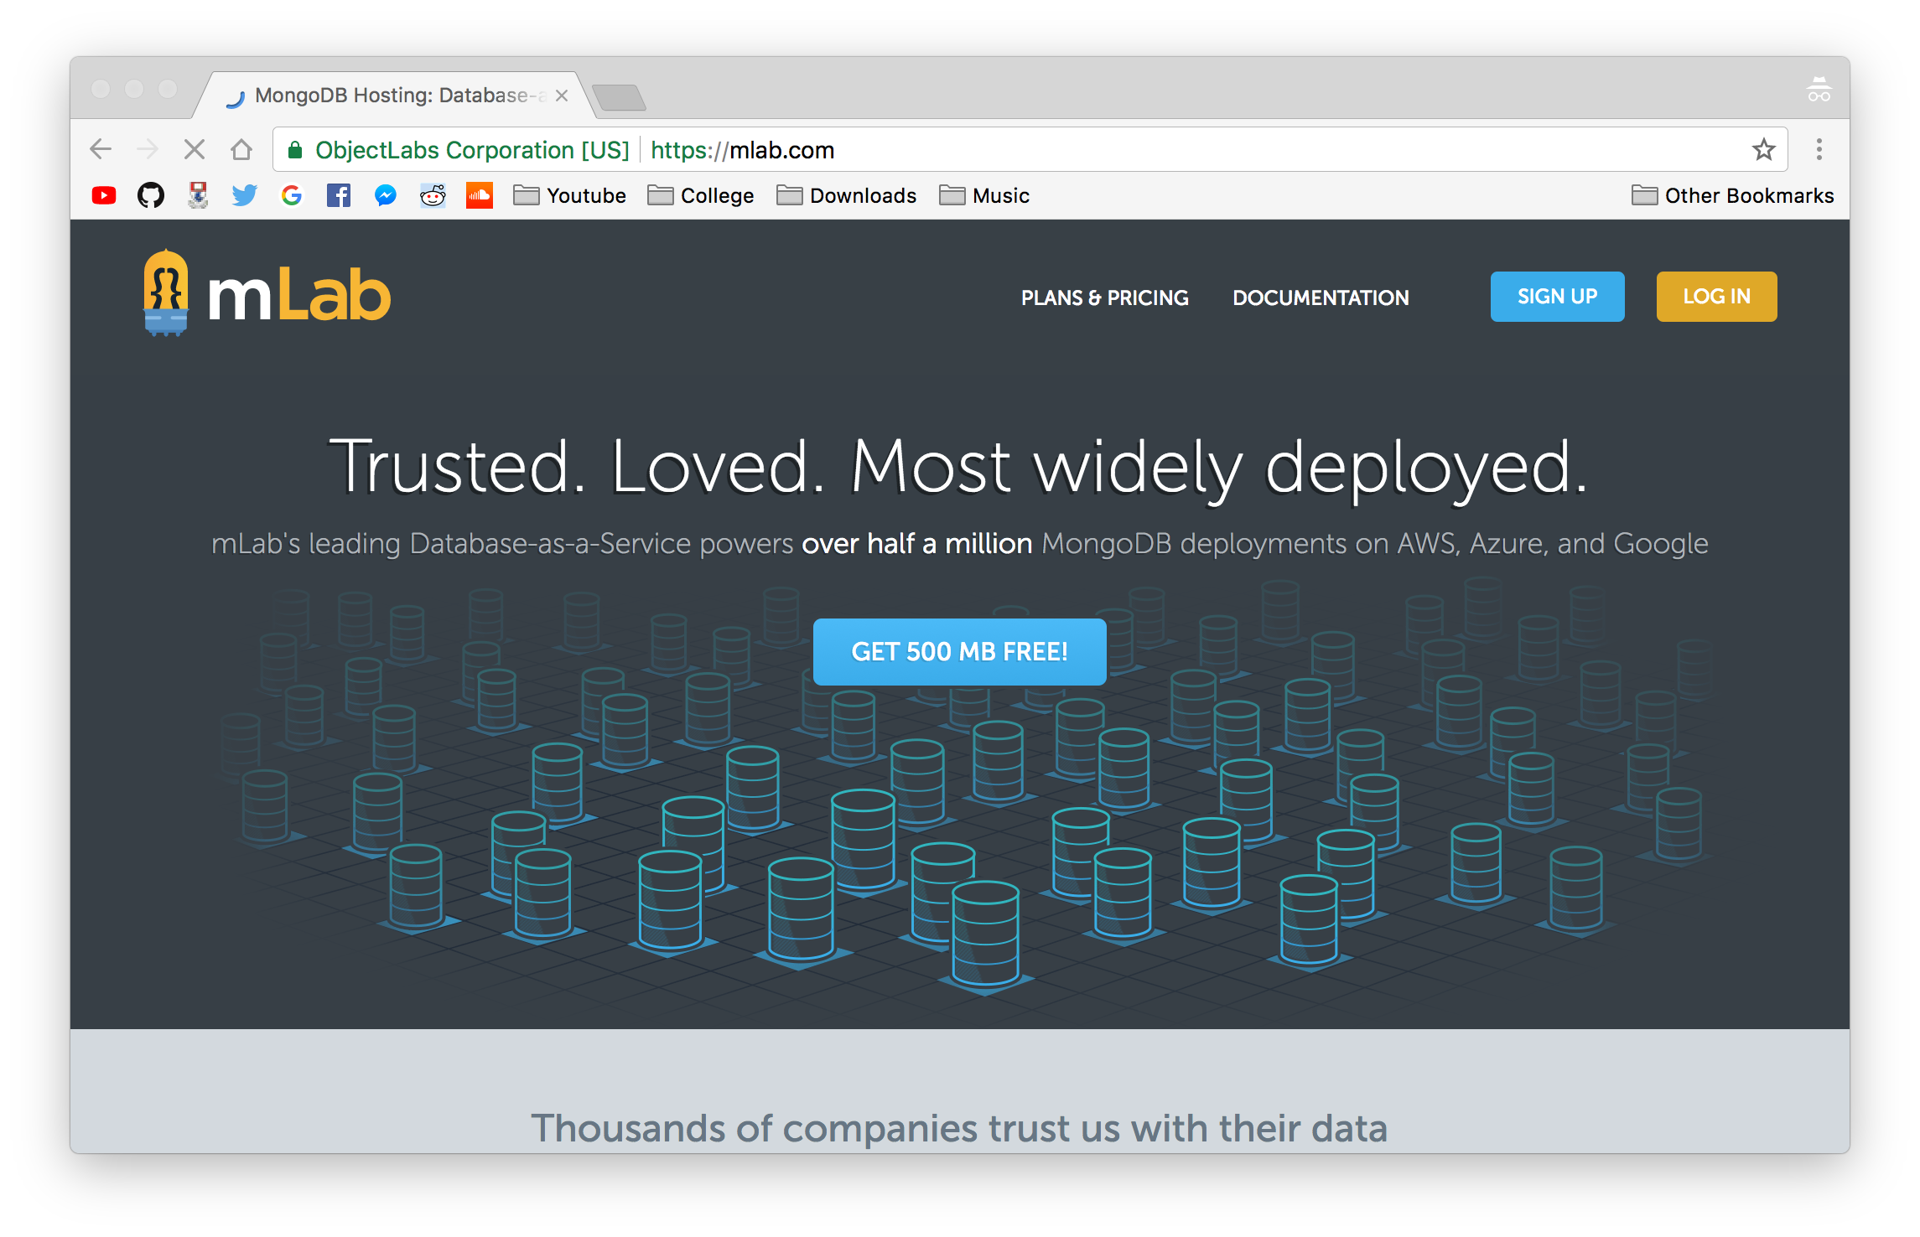

Figure 6: <https://mlab.com/signup/>

After creating an account with mLab I proceeded to create a database named *Spotify-nosql*

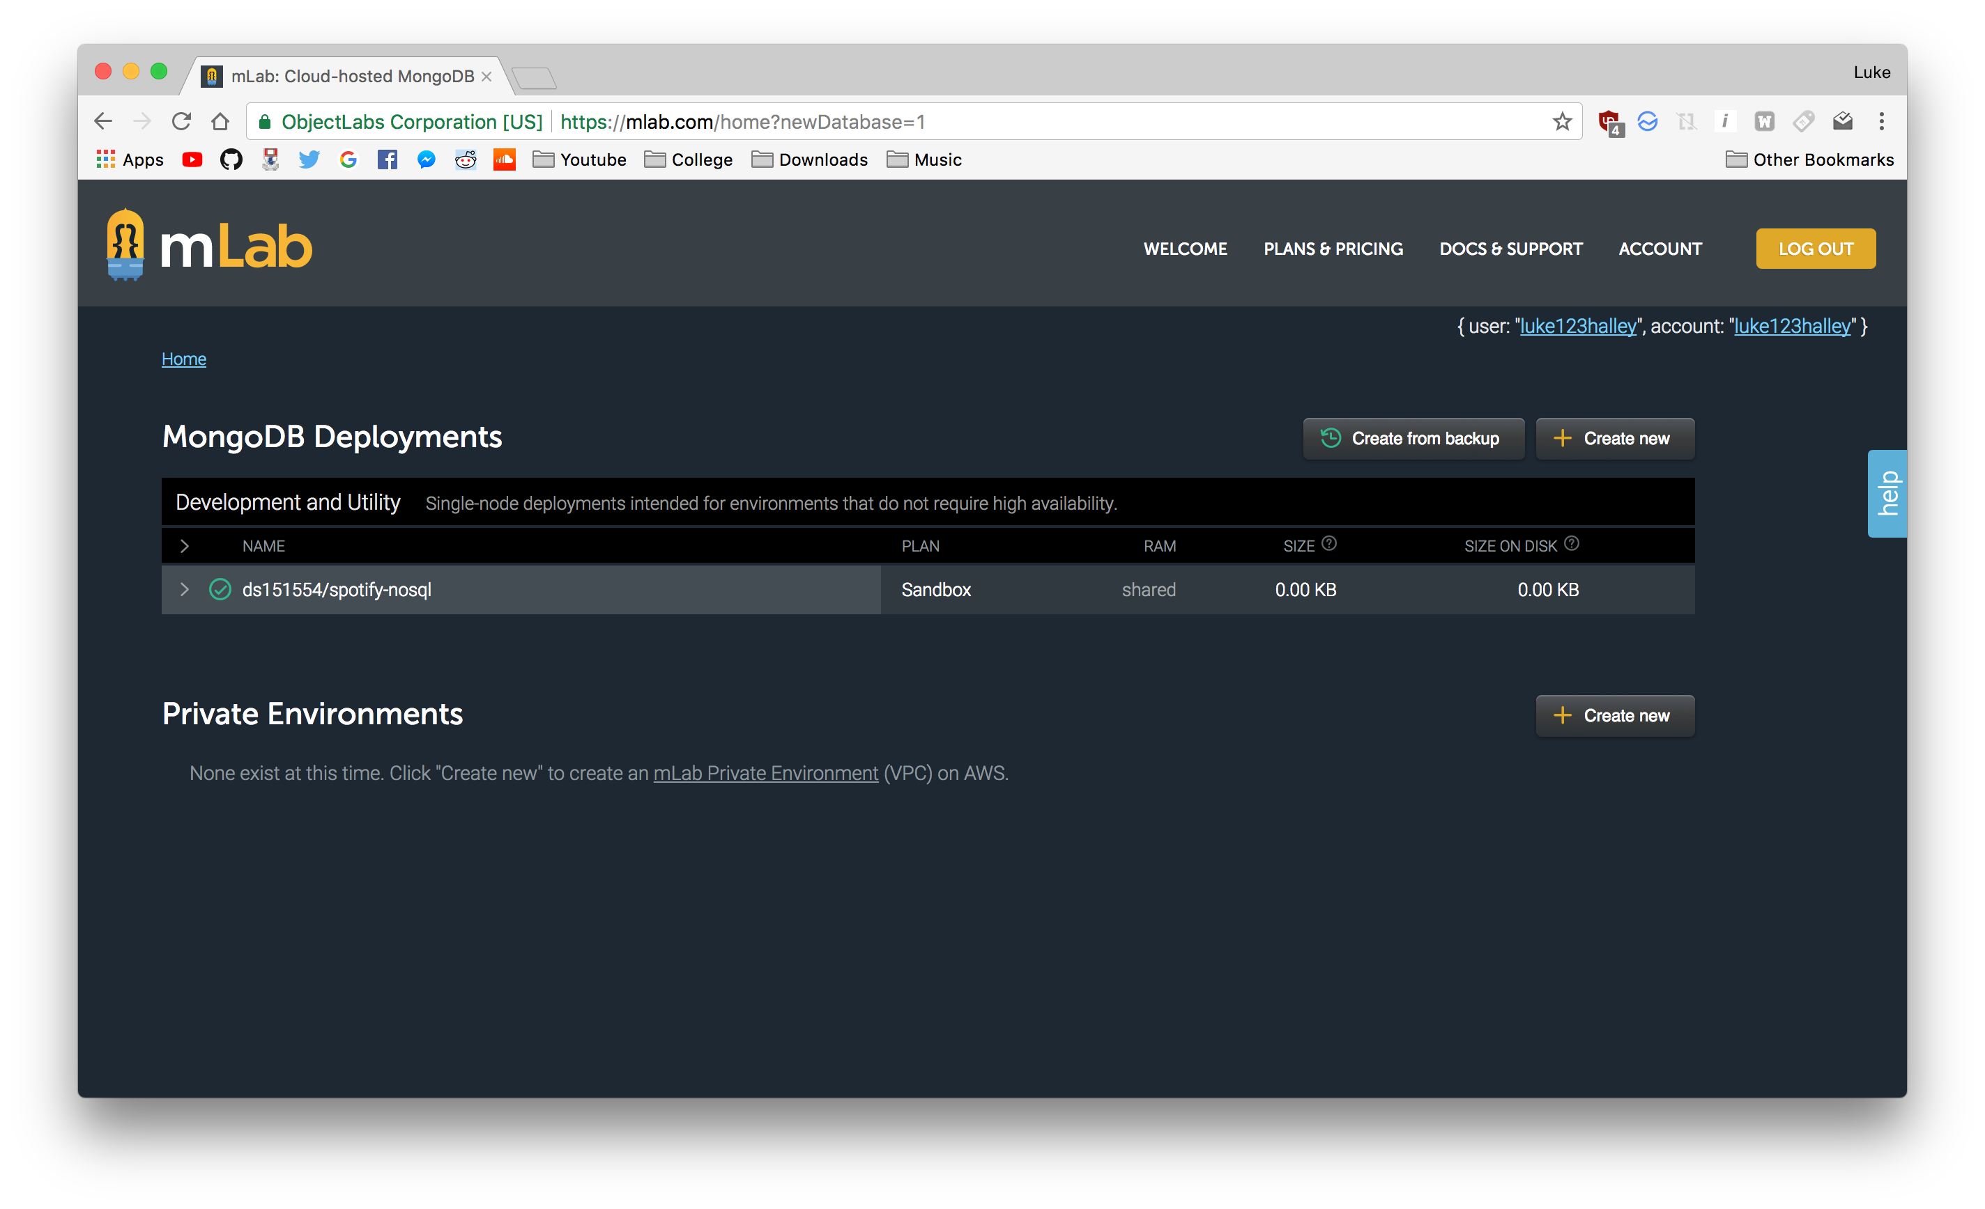

I then added myself as a user to the database

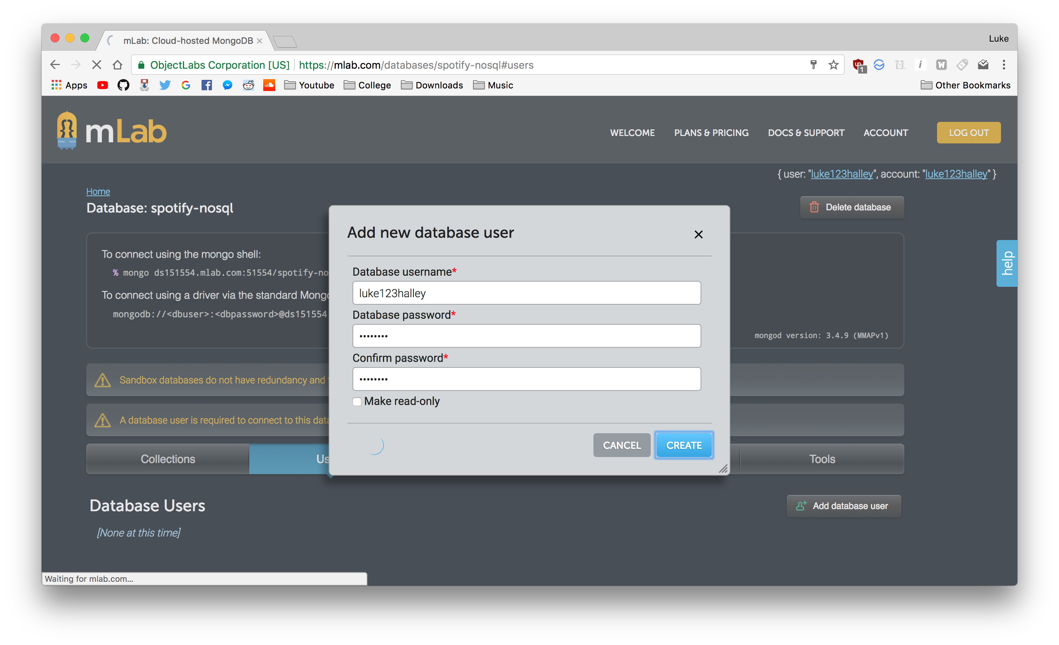

Connecting via the mongo shell (note: I changed my credentials between these screenshots)

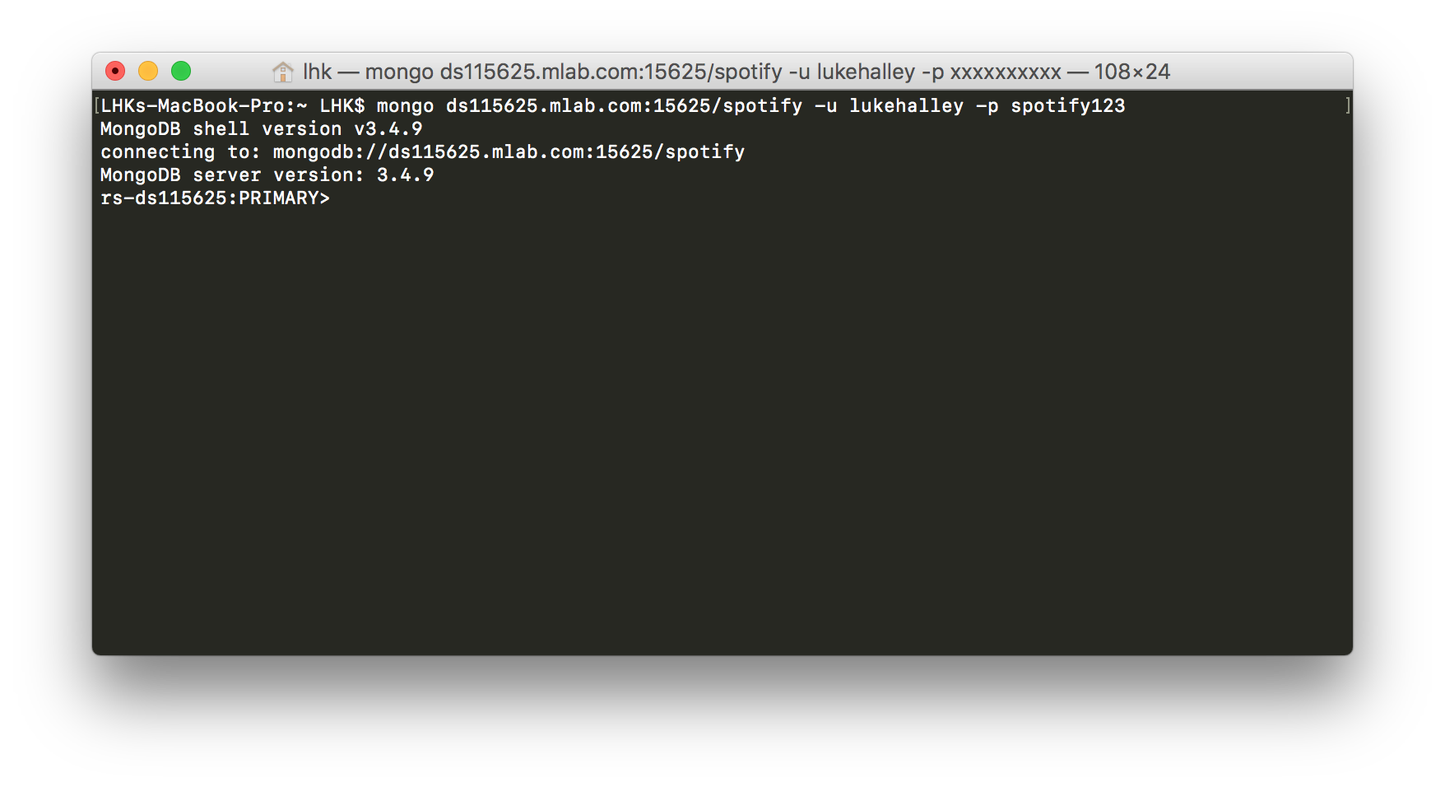 Changed the database to Spotify

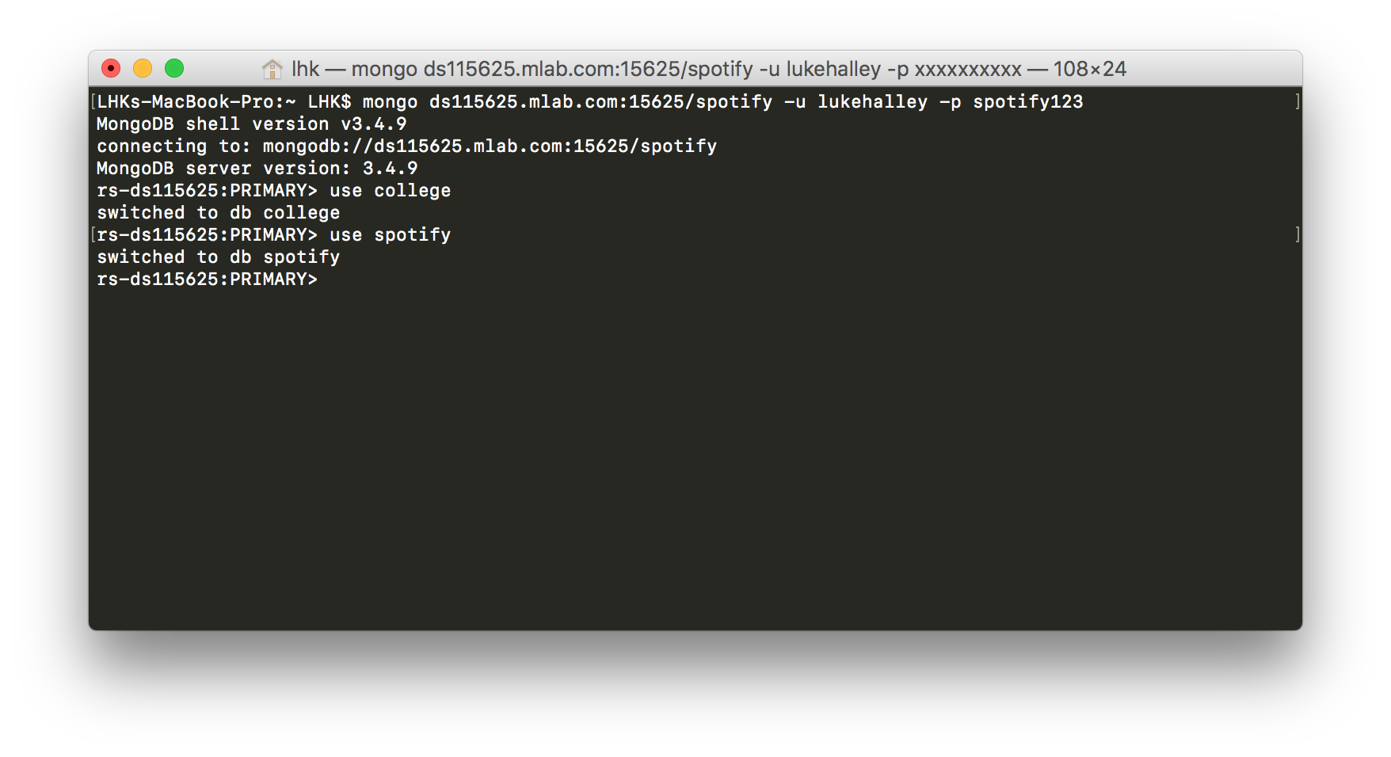

*Figure 7: "use spotify"*

# Creating Documents

There are two methods of adding Documents to mLab:

1. Using the command line

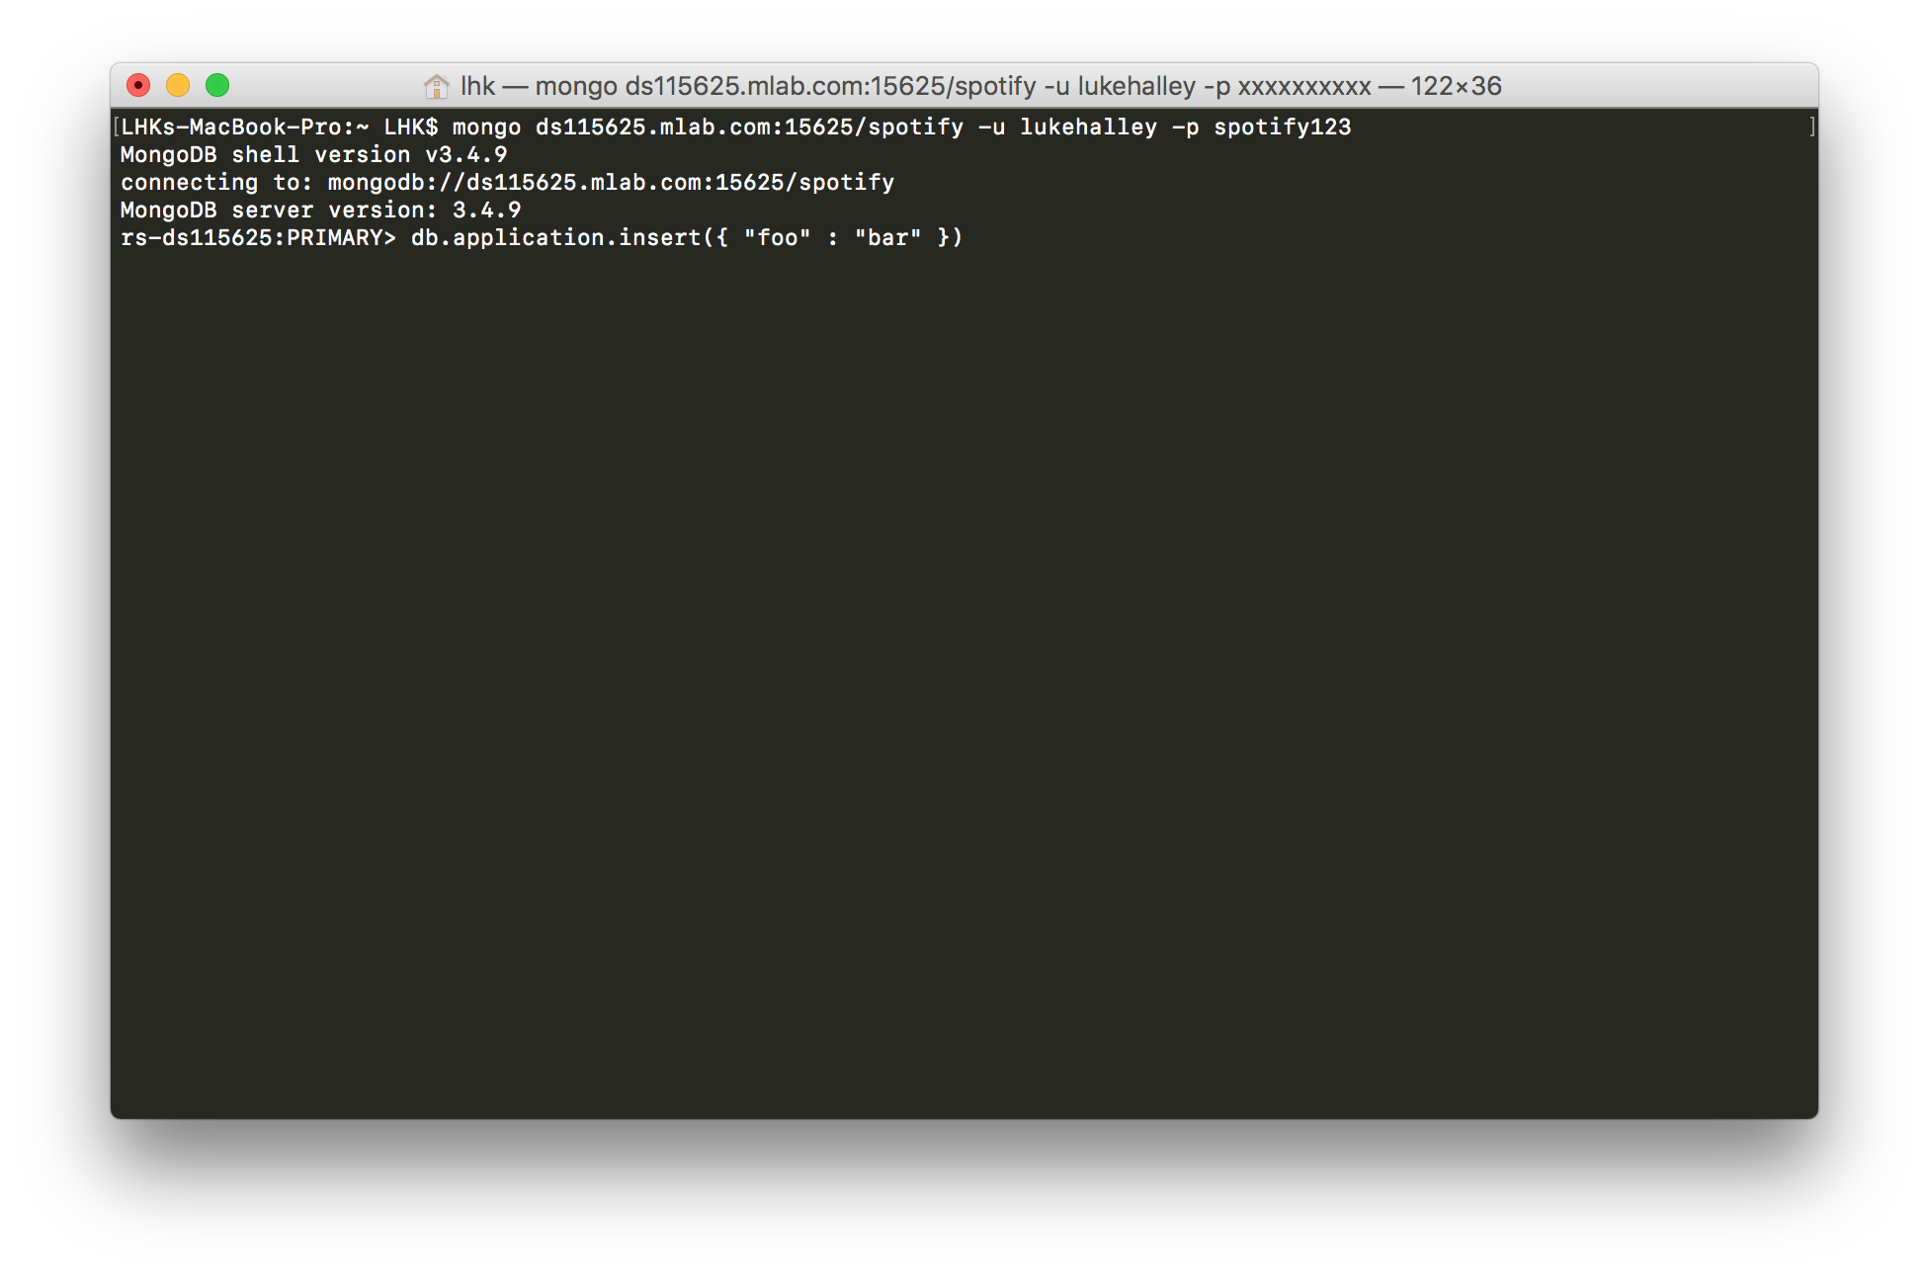

1. Using the mLab GUI

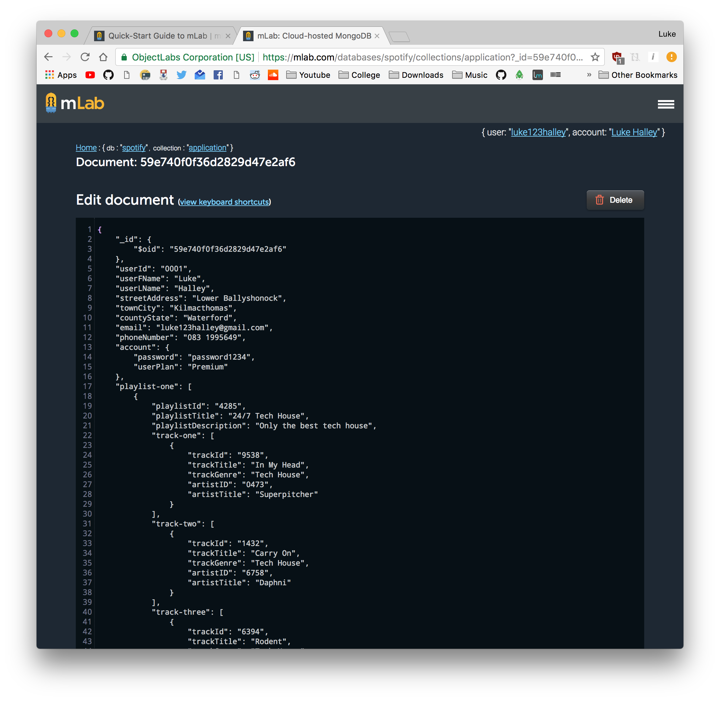

Since this was my first time using JSON (the language NOSQL databases uses to store its document information in, I had to learn the basics first before I could start implementing my database. When writing my code I use the text editor “Sublime Text” to write out the code and copied it over to the mLab GUI to write it to my database.

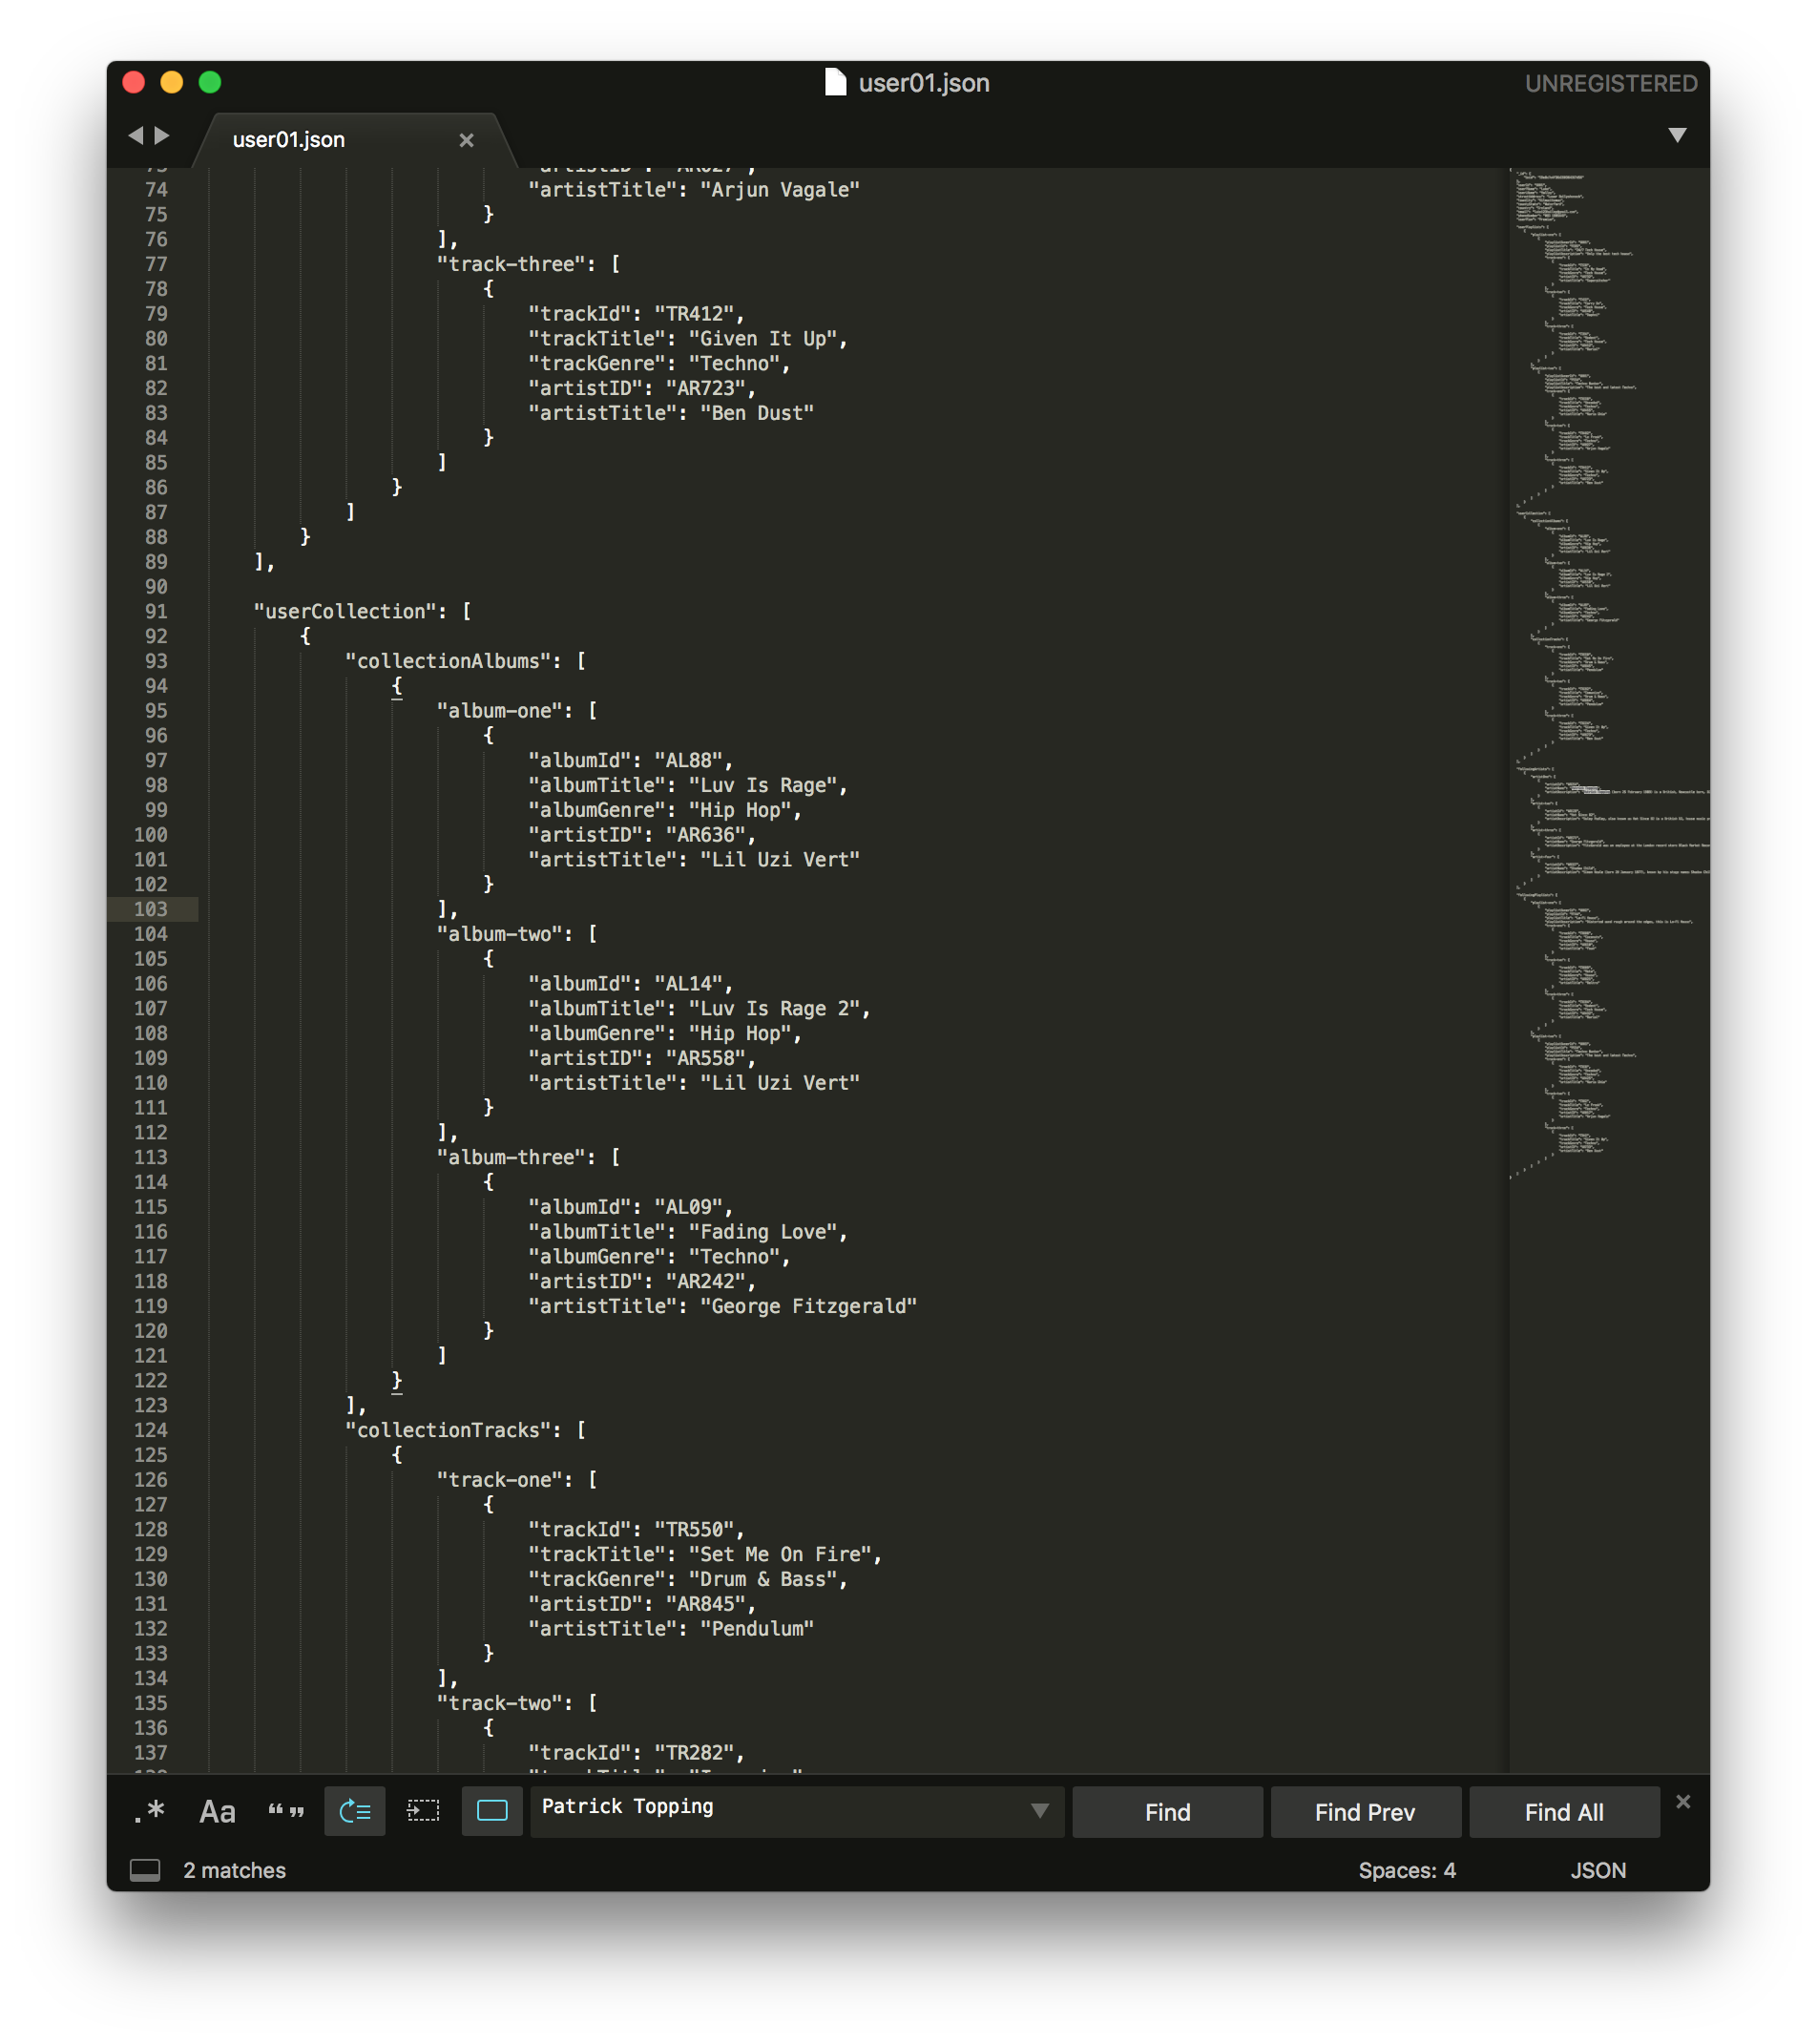

I also used JSONLint (<https://jsonlint.com)> to compile my JSON code and find any errors in it.

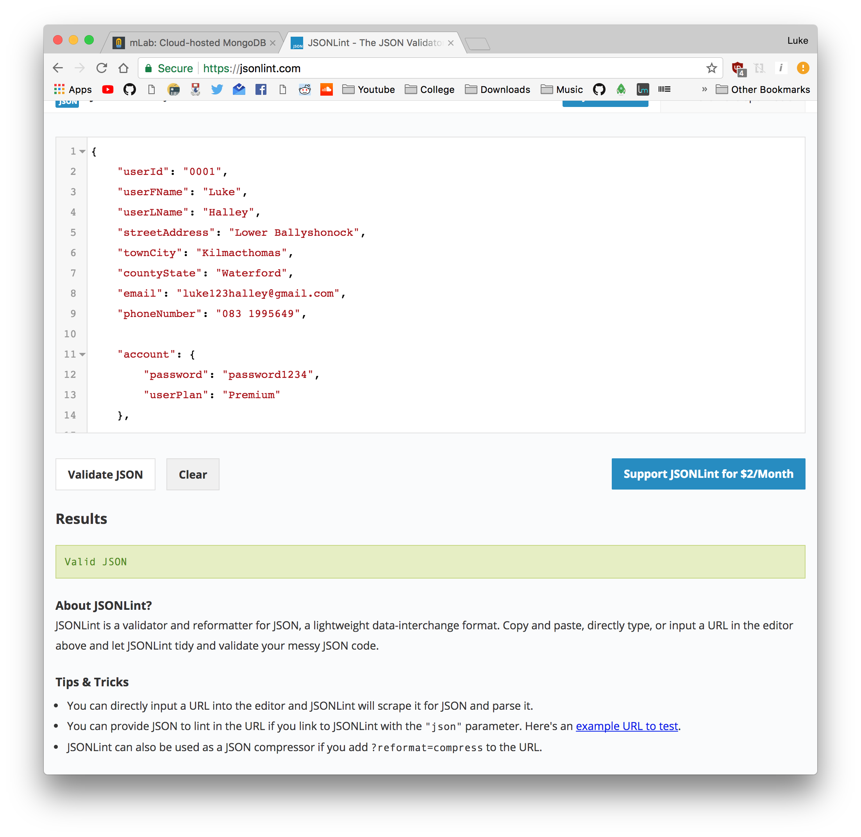

I decided to name the collection “application” as the database is modelled off the Spotify platform. mLab allows you to view all your documents in two views;

* List: shows each document in a list form with the JSON code.
* Table: allows you display all documents in a easily viewed table, its formatted using the *edit table view* formatted in JSON.

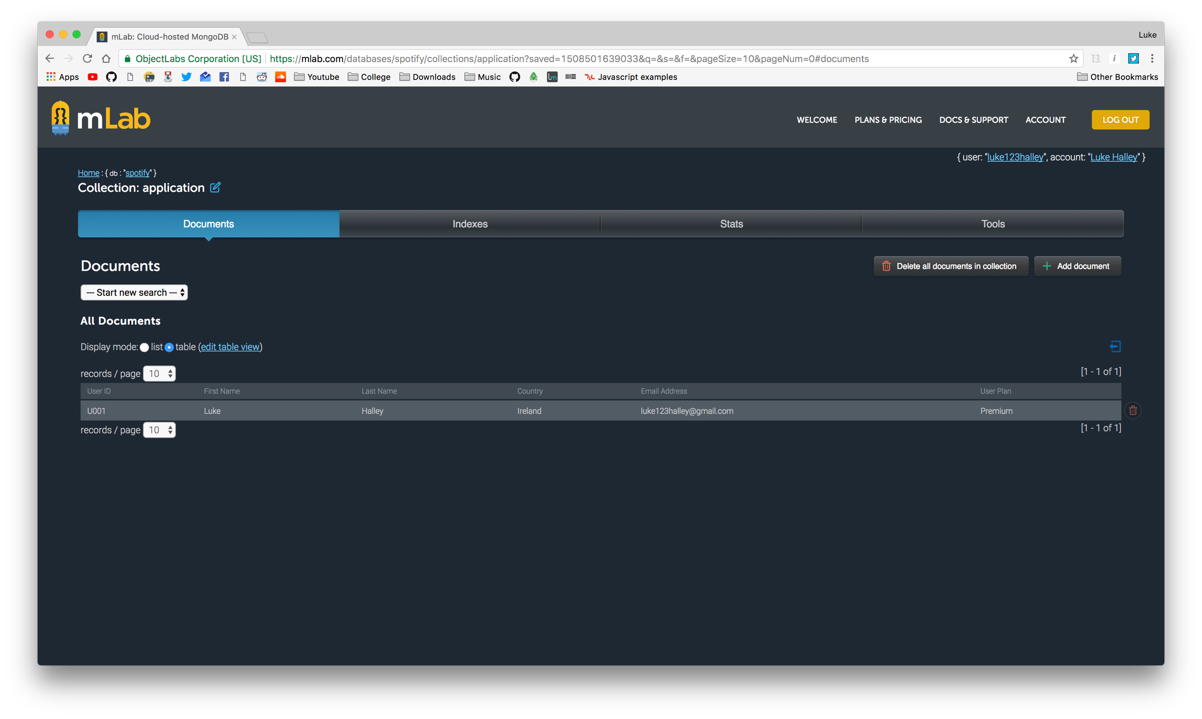

***Note: $date cannot be used in the shell, only in the REST interface and in the tools like the mLab GUI. This is also one of the reasons why I used the mLab GUI:***

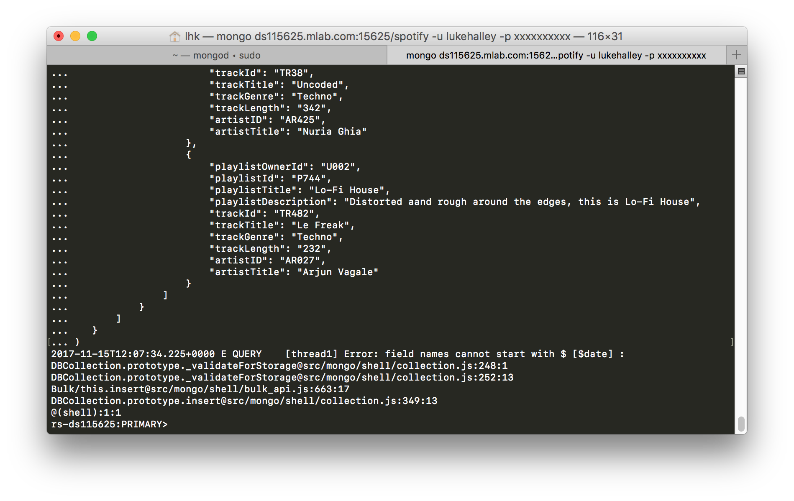

# Inserts

Note: All code is also available on the following Github repository: <https://github.com/lukehalley/NoSQL-Spotify>

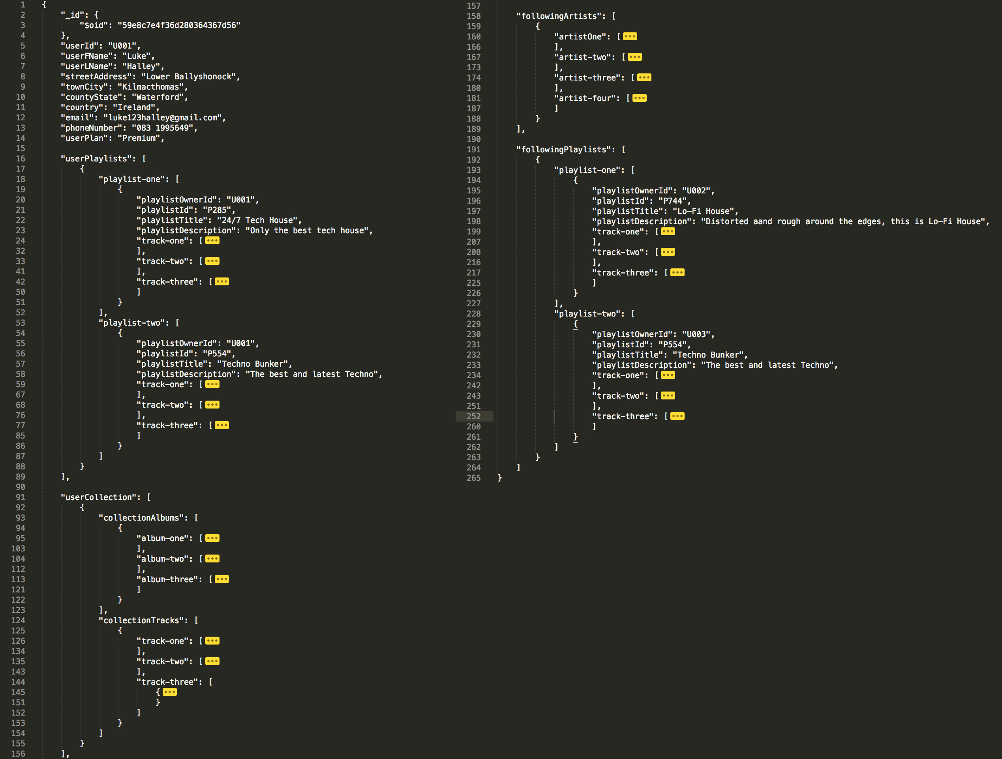

*Figure 8: https://github.com/lukehalley/NoSQL-Spotify/blob/master/Code/user01.json*

# Queries

To display the document in a readable format the “pretty” command was used

pretty();

Find the document with the userId: **U001**

db.application.find({"userId":"U001"}).pretty();

Find the documents with the email: **cormacdunphy@gmail.com**

db.application.find({"email":"cormacdunphy@gmail.com"}).pretty();

Calculate the number of users that have premium plans:

db.application.find({"userPlan":"Premium"}).count();

Calculate the number of users that have free plans:

db.application.find({"userPlan":"Free"}).count();

Calculate the how many albums from the Artist “Lil Uzi Vert” are in the collection

var t = db.application.find({"userCollection.userAlbumCollection.artistTitle": "Lil Uzi Vert"}).count();

print (t);

Show how many people signed up after the year 2000:

db.application.find({ "signupdate" : {"$gte": new Date("2000-01-01T00:00:00.000Z")} }).count();

and before the year 2000:

db.application.find({ "signupdate" : {"$lte": new Date("2000-01-01T00:00:00.000Z")} }).count();